**User guide**

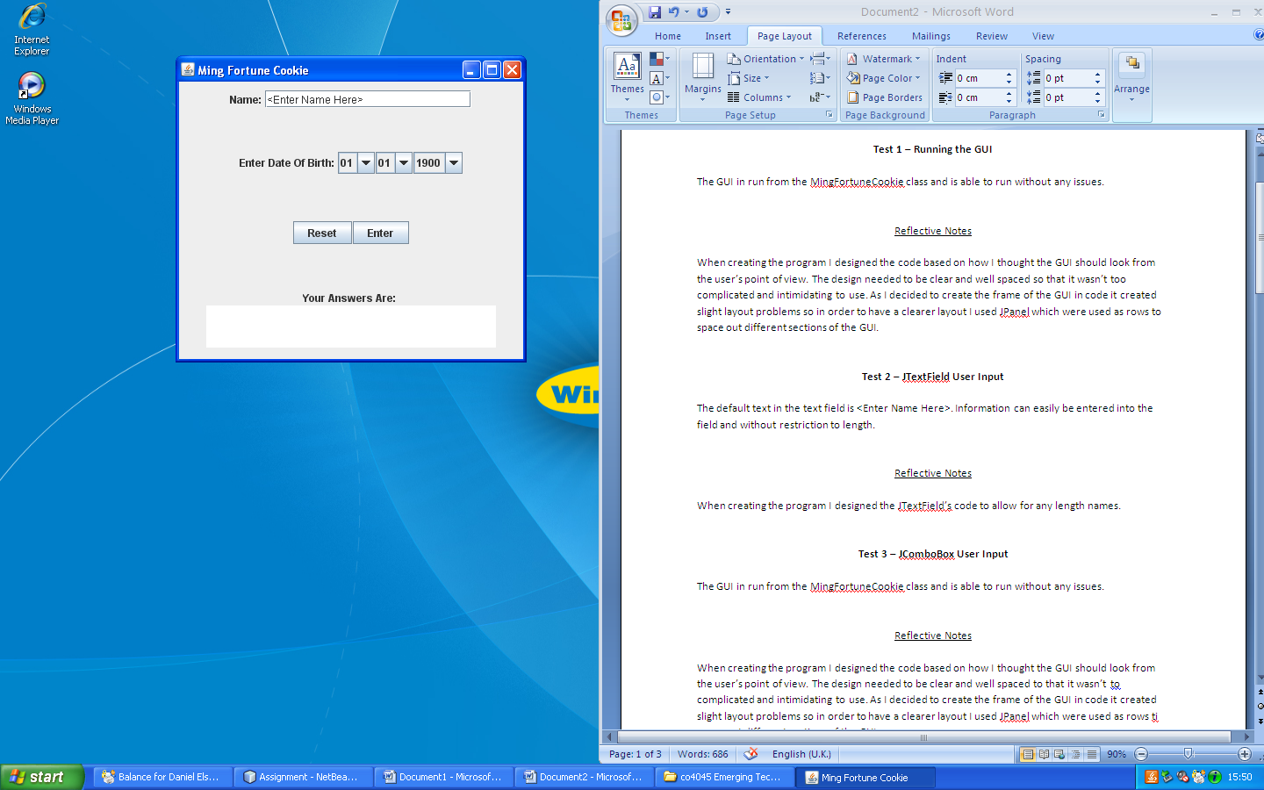**Entering your name**

First enter you name into the text field provided as shown in GUI to the right.

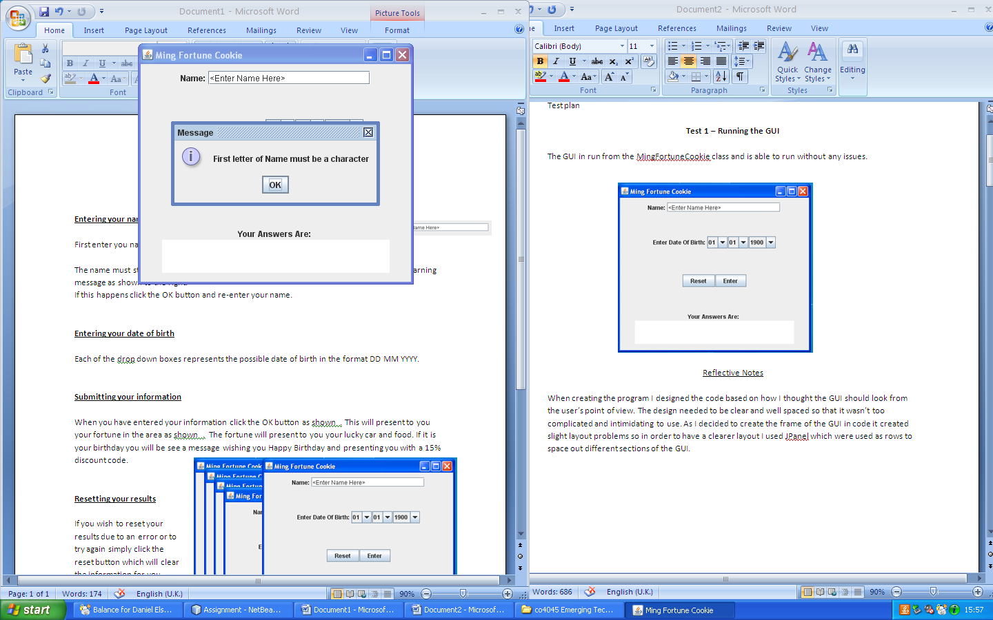

The name must start with a letter; if this condition is not met you will be presented with a warning message as shown to the right.

If this happens click the OK button and re-enter your name.

**Entering your date of birth**

Each of the drop down boxes represents the possible date of birth in the format DD MM YYYY.

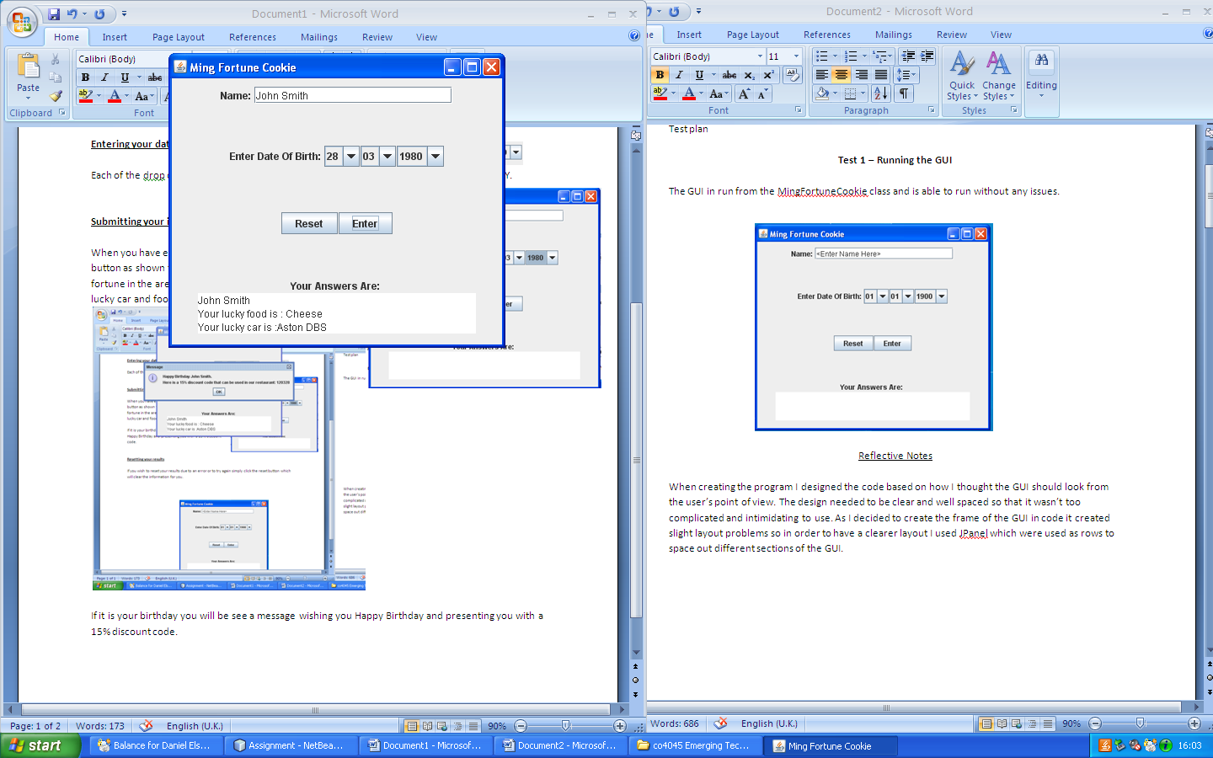

**Submitting your information**

When you have entered your information click the OK button as shown to the right. This will present to you your fortune in the area. The fortune will present to you your lucky car and food.

If it is your birthday you will be see a message wishing you Happy Birthday and presenting you with a 15% discount code.

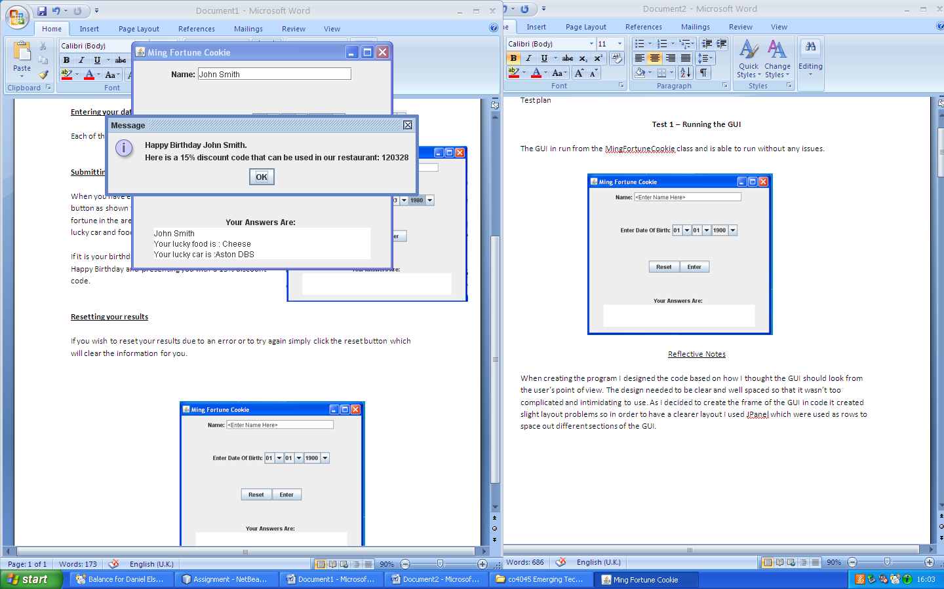

**Resetting your results**

If you wish to reset your results due to an error or to try again simply click the reset button which will clear the information you input are set everything back

to default.